**Wells Fargo**

52 week 8.01 - 31.53

**28.89 as on March 8, 2010**

**Union Bank, San Francisco, CA 1.5yrs(18m) Aug 2008 – Present**

***400 California St., SFO, CA(sansome and Montgomery)***

**Montgomery.**

**Citibank, San Francisco, CA 1.5yrs(18m) Feb 2007 – July 2008**

**245 Market St, San Francisco**

**Embarcadero. Office is right on market.**

**52 week 0.97 - 5.43**

3.50 as on March 7, 2010

**Standard Chartered Bank (Wholesale), Pasadena, CA Jan 2006 - Jan 2007**

**790 E. Colorado Blvd., Suite 808 1 yr (12 m)  
Pasadena, California 91101**

**Yahoo Inc., Sunnyvale, CA 1.5yrs(18m) July 2004 – Dec 2005**

**701 First Avenue  
Sunnyvale, CA 94089**

**880S - 237W - Caribbean Dr. Exit**

52 week 12.51 - 18.02

16.52 as on March 9, 2010

**First Funding Financial Services, Denver, CO 1.5yrs(18m)** **Dec 2002 - May 2004**

**4704 Harlan Street  
Denver, CO 80212-7418**

**All State Insurance, Northbrook, IL 20m April 2001- Nov 2002**

### 2775 Sanders Road Northbrook, IL 60062

ALOK

METHODOLOGIES?

MY ROLE IN WHOLESALE BANKING

PROJECT RISKS

**ABOUT YOURSELF**

I am an MBA and have been working for over 8 years as a Business analyst in various domains like Banking, Finance, Insurance and Technology with most experience in Banking.

I started working as a BA in 2001 with an Insurance company, but soon moved to the Banking sector in 2002 with First Funding Financial Services. Over the years as I moved from one project to the other, my **leadership skills**, being a **good team player**, being a conscientious **worker**, **detail oriented**, **ability to analyze and resolve issue** graduated me to the role of a Sr. Business Analyst. I enjoy working with local and distributed teams. I believe I work well under pressure and strict deadlines. In my last project, I got an opportunity to step into the shoes of a Project Manager for some time.

I possess strong Business Analysis Skills and a thorough understanding of various SDLC phases like Requirements Elicitation, Analysis, Design, Development and Testing. I have made contributions to each of these phases and what has helped me most are my listening and communication skills, my ability to build strong inter personal relationships and my capability to understand the other persons point of view. I am well versed with different SDLC methodologies such as Agile, Waterfall, Rapid application development, Joint Application development and rational unified process (RUP). I have extensive experience in various BA tools and documentation styles. I am able to meet stringent deadlines and have the capacity to work well under pressure

**Analytical, amiable, expressive or driving initiative, patient, Accomplish, superior team management**

**Citibank, San Francisco, CA Feb 2007 – July 2008**

***Sr. Business Analyst***

**Client Brief**

Citigroup Inc. (NYSE: C), is today’s pre-eminent financial services company with some 200 million customer accounts in more than 100 countries. The major brand names include CitiCards, CitiFinancial, CitiMortgage, CitiInsurance, Primerica, Diners Club, the Citi Group Private Bank and CitiCapital.

**Project: Receivables Vision Banking**

The project was about creating a web-based solution called **Receivables Vision Banking (RVB)** that would offer **integrated online receivables management solutions** and tools across all payment and funding channels, be they paper **(lockbox)** or electronic(**ACH, Fedwire etc)** or credit based (credit card payments). The application would also provide analytical tools, which will facilitate online monitoring and reporting by the customer.

**Responsibilities**

* An active member of the **Requirements Management team** whose function is to integrate and manage requirements.
* **Assisted Project Manager** in developing **project plan and creating and maintaining project documents**
* Defined high-level actors**, artifacts and use cases** reflecting system scope for the **Lockbox, ACH, PEP, Treasury etc.**
* Performed project management activities for full project life-cycle following the **Agile** iterative development process
* Gathered and documented business requirements at a high level and aided in design.
* Conducted user interviews and **JAD sessions** as a part of the requirements elicitation.
* Worked with the **RUP framework**, involved in iterations at each phase of the Software Life Cycle.
* Conversion and Implementation of a **Wholesale** **Lockbox** System and Formation of Upstart **Lockbox** Department.
* Customized RUP according to the standard operating procedures and developed a **Requirements Management Plan.**
* Coordinated in gathering integration requirements between different modules and translated it in a proper manner to the developers accordingly for each production cycle by cresting **Traceability Matrix** using **Rational Requisite Pro**.
* Active member of the **Change Control Board (CCB)** and conducted **GAP Analysis** to regulate the gaps in the requirements and conveyed it to the various modules of the project and to the off-shore development team.
* Bridged the gap between the off-shore and on-site teams in terms of Requirements Management.
* Performed quality audits of the requirements and distributed it to all the stakeholders.
* Associated in the change control process and used **Rational Clear Case** for version control and unified change management.
* Conducted functional walkthroughs to ensure all the business requirements were met and assisted in the development of User Manuals.
* Defined a change management process and developed a change request record type in **Rational Clear Quest** and integrated it with the Requirements in **Rational Requisite Pro**.
* Worked actively in the development of Rational Project console and worked towards creating reports and metrics for the upper management.
* Helped with the **UAT** by writing test cases and identifying test scenarios.
* Wrote SQL queries for Business Logic.

**Environment:**

Windows 2000, Java, XML, HTML, Oracle 9.1, SQL Server 2008**,** RUP, MS-Visio, Rational Clear Case, Rational Clear Quest, Rational Requisite Pro, MS-Project, MS Office Suite

**ABOUT CITIBANK PROJECT** 245 Market St, San Francisco

Get down at embarcadero. Office is right on market.

**52 week (52 weeks high low 0.97 - 5.43)**

Stock price: 3.50 as on March 7, 2010

**Tanu’s concern about “What was her role? I am not able to figure out what my role was?”**

***Alok’s answer:*** Your role in this project was to be the BA gathering requirements. Just like your role in a NASA flight launch application would be to gather requirements. The only difference between a NASA BA and Tanu Priya Gupta will be that the NASA BA will know about space shuttle launch requirements, would perhaps revisit Kepler’s laws again, what is the rate at which fuel burns in a ship, etc., whereas Tanu Priya Gupta will know what is a lockbox, what is ACH, how a bank lets the wholesale customer know what payments have been received, etc..

**Tell me about this project?**

**Citibank project was primarily a Wholesale banking project.**

The aim of the project was to offer its wholesale customers an **Online Receivables Management Solution (RMS)** where a customer would now have access to various tools and services like Speed Collect, Speed Collect Lockbox, etc.

Using these services customers would set up all the accounts receivable tasks and have the bank work on them on their behalf. Now all this could be done easily **online.**

This **accelerated the availability of funds for the customers** resulting in **better cash flow** thus **decreasing the working capital** required.

Our application helped the customers in

1. Reducing daily outstanding (receivables)
2. Integrating efficient collection process
3. Faster, automated and accurate reconciliation
4. Improving operational risk management and controls.

**Question from Tanu**: The above answer is a very business related thing. When someone asks me, “What is this project about?”, is it required to say these 4 bullet points? **Alok’s answer**: Absolutely. You are a BA. They are looking at you as a BUSINESS PERSON! A person who can come in and understand the high level business processes, understand what we do for the customer, how are our customers dependent upon us, what value we provide them! Indeed, the role of a BA is much more functional than technical and Alok only makes his class technical to give you guys a hard time (and to give you a little bit of birds eye view of how technology works).

YOU HAVE TO HAVE TO HAVE TO talk from business perspective more than technical perspective. It is just that you should not be tongue tied when someone does throw a technical term at you and you are able to have a little bit of conversation! Of-course, this is assuming you are going for a Functional BA position which is what most BA positions are out there! If you are going for a Technical Analyst (Systems Analyst position), at that time, perhaps you will have to talk a bit more technology.

**Give me details of the project?**

The **suite of products** and services being offered included:

1. Speed Collect
2. Speed Collect Lockbox
3. Speed Collect Remote Check Collections
4. Speed Collect Funds Transfer Collection
5. Speed Collect Virtual Account
6. Direct Debit

*I SO SO SO MUCH APPRECIATE CANDIDATES WHO WRITE IT DOWN! SPURS ME TO HELP YOU IN THE BEST POSSIBLE WAY!!! Thank you Tanu!*

When I joined the company, these services were available. However, they were not available online.

The communication between all the entities involved, was physical. Either through physical mails (Mailers) or telephonic

Disadvantages of the same from Customer perspective:

* 1. Time consuming communication between each entity
  2. Delays in receivables
  3. Delays in account reconciliation
  4. Low Cash flow for the customer thus requiring more Working Capital

TREMENDOUS USE!!!!! BUSINESS PERSPECTIVE!!!

In today’s competitive world, every bank or company wants to provide the best to its customers. In an endeavor to do so, bank wanted to **offer all the services online.**

Advantages from Citibank perspective

1. Increase client-to-staff ratio through greater automation
2. Improve client service
3. Reduction in operational overheads
4. Minimize time and cost input
5. Workflow driven actions : Designed with a workflow engine at its core that provides full and flexible automation for standard business processes

**Team Size**

Project Manager-2

BA-4

QA-10

Developer-8

**My role as a Business Analyst** started right from requirements gathering through production.

I gathered requirements for the project where the entire suite of services was to be made available to the customers **online.**

I was responsible to make sure that all the business rules were duly incorporated during documenting requirements. I also assisted the Project Manager in developing project plan and creating various Project Documents. …BRD, FSD, Use Cases, Use Case Diag (Activity Diag), ER Diag.

As Part of his project I also conducted JAD Session and was part of the Change Control Board. I assisted the QA Teams in Identifying, writing and executing test cases.

**Business Rules/Policies** like:

1. Implementing changes within the scope of Federal Reserve System.
2. It will take you a few days to keep thinking about this. Constantly evolving document!

**What other things should I add?**

Look in “Why do I ask for Project write ups” and add answers to questions from there!

**Question from Tanu:** From Monday perspective (interview is only 36 hours away), what more should I prepare? What should I focus on?

**Alok’s answer:** 1) Is every write up of this quality? If not, then, that is what you for the next 36 hours! Yes, I know it is hard work! It seems boring but that is the only way to be confident on Monday at 12:30 pm!

From Monday’s perspective: If I was the interviewer, would I ask you anything else! Wow! If I knew the answer to that question, I would open up a mind reader shop and make money!!!!!

To give you an example of the type of **Business Requirements** I gathered:

LOVE IT!!!!!!! YOU ARE AWESOME!!!! IT is never sufficient. It is like Ramayan! Keep adding to it!

1. The monthly billing cycle would be from 5th of every month till the 4th.
2. The customer will be able to write off receivables online
3. The customer will be able to update the database (A/R data) at anytime
4. The receivables will be compiled on a daily basis
5. Reconciliation statements will be available online to the customer.
6. Customer may online check the receivables, the age of debts, debts written-off at any time.
7. The format of the reports and statements should be .xls or pdf
8. Online integration of the customer and the bank system. ( When customer’s system is updated with A/R information, it automatically gets updates in the bank servers as well.)
9. Alerts and reminders should be sent out to the customer debtors

**What type of ISSUES FACED DURING THE PROJECT?**

Issues faced in the project:

1. Citi SpeedCollect, a brand new concept that was initiated at a senior level, I was responsible for gathering requirements from the actual wholesale business team users. I had a tough time convincing them about the viability of this concept. They were not ready to buy into this project’s essence. I had to do numerous user focus groups with the business team to explain to them how this can drasticall increase the revenue for the group and solidify Citi’s positions as a mainstream wholesale bank.
2. Being a novel idea that very few other banks had implemented in USA, the requirements were very unclear to begin with. I had to study the offerings of our competitors in the same space (like ING, Standard Chartered bank).

**RISKS INVOLVED IN THE PROJECT?**

1. Bringing this unprecedented amount of data online required us to re-evaluate our hardware capacity. So far, the wholesale customers business with Citi was largely manual and paper based. To bring this business online, means the capacity planning group had to estimate how much more hardware will be needed in our data centers. “Capacity overruns will happen causing loss of customer data affecting our project’s success”
2. Customer authentication and authorization had to be fully documented because with all the business transitioning into online space required Citi to fundamentally rethink how to authenticate its customers. I worked on a project with Citi to help remove risks like Phishing!
3. Customer’s clients co-operation! Since Citi is now recovering receivables for its customers, customer’s customers have to buy into this new business paradigm.
4. **Speed Collect** – Helps to collect and manage receivables.

This product is designed to accelerate collections and improve the processing efficiency of accounts receivables, and to facilitate outsourcing the Collections process to Citibank. With a variety of collections options covering the country, Citibank takes the collection process beginning at your offices and locations and links it directly to the Bank and to your account, ensuring fast access to your funds as well as precise and timely information. Benefits include:

* Efficient Collections
* Concentration account for maximised funds flow and yields
* Reliable Cash Flow projection
* Improved Liquidity
* Information at your fingertips via CitiDirect Online Banking
* Security

Our range includes Citibank SPEEDCOLLECT - Cash Collections, Citibank SPEEDCOLLECT - Cheque Collections

1. **Speed Collect Lockbox** – The integrated outsourcing solution consolidates funds in various currencies. The information is captured using a variety of channels including imaging, and is delivered to the customer electronically for them to upload into their enterprise resource planning (ERP) system.

This service consolidated the funds of the customer and electronically delivered to upload into their ERP

**Lock box banking** is a service offered by commercial banks that simplifies collection and processing of account receivables by having payments mailed directly to a location accessible by the bank. If you pay your electric or water bill with a paper check, it will likely go to a lockbox department at a bank.

Lockbox services are sometimes called 'Remittance Services' or 'Remittance Processing'.

**ERP (Enterprise Resource Planning)** – It is a Software Architecture which facilitates the flow of information between all business functions within the boundaries of an organization.

It is built on a centralized database and normally utilizing a common computing platform, **ERP systems consolidate all business operations into a uniform and enterprise wide system environment.**

1. **SpeedCollect Remote Cheque Collections -** Our tightly controlled authorised agents collected cheques from even the most remote locations. Cheques sent to Citi branches or correspondent banks were assured of prompt processing and clearing.
2. **SpeedCollectSM Funds Transfer Collections -** With membership in all major payment and clearing systems Citi can collect all electronic incoming payments, both domestic and cross-border, and capture the relevant information for the customer to reconcile accurately.

**How does speed collect work?**

Answer: Sounds like. Yes!

1. **SpeedCollectSM Virtual Account –** Reconciliation solution that helped the customer match their accounts receivables. The incoming Cr. Information is delivered to the customer in an electronic file and the data can be used to automate both bank account and open accounts receivables reconciliation.
2. **Direct Debit** –The customer had full control of receivables using electronic file solution …Done using ACH.

**ACH** is an electronic network for Financial transactions. ACH processes large volumes of **credit** and **debit** transactions in batches.

**Credit:** Direct deposit payroll and vendor payments (Crediting the accounts with salaries, etc.)

**Debit:** Accepting Consumer payments Ex. Premiums, mortgages (Auto debit is set from the customer’s account)

Rules and regulations governing the ACH network are established by [NACHA](http://en.wikipedia.org/wiki/NACHA-The_Electronic_Payments_Association) (formerly the National Automated Clearing House Association)

1. **Retail Collections** – wide network of convenience stores and post offices enables our customers to collect bills and other payments from their clients. Information and consolidated reports are delivered to their ERP system.
2. **CitiConnectSM Web-Enabled Financial Services** – This enables the customers to settle the online transactions across their supply chain, thus improving online availability of receivables information.

**RECEIVABLES MANAGEMENT SOLUTIONS**

[**http://www.online.citibank.co.in/portal/newgen/corporate/global_commercial_banking/NRB/receivable_manage.htm**](http://www.online.citibank.co.in/portal/newgen/corporate/global_commercial_banking/NRB/receivable_manage.htm)

The receivables solutions

1. **accelerate the availability of funds** and
2. **help the clients monitor their customer credit risk using updated information**.

At Citi, we understand the challenges of managing labor-intensive, time-consuming receivables duties. We are here to help you streamline the processes and add value across your entire organisation. Citi’s Receivables Management Solutions use various collection channels to collect your receivables quickly, and at reduced cost, delivering your information through a variety of reports using our secure online banking platform. The benefits quickly translate to improved operational efficiency and customer service.

[Benefits](javascript:showhide('d1','imgd1'))



* Reduce Days Sales Outstandings (DSOs) through accelerated collections
* Integrated, efficient collection process
* Better control of cash flow and collections
* Faster, accurate and automated reconciliation
* Help you expand your distribution network
* Utmost convenience for your customers
* Improved operational risk management and controls
* Local language capability



[Automate your reconciliations](javascript:showhide('d3','imgd3'))



Our team of experienced electronic banking and implementation professionals can work with your team to automate your cash application process. We have successfully integrated receivables information to a variety of ERP systems. We also offer a wide range of receivables reports in CitiDirect® Online Banking, available in industry standard formats.

With integrated online receivables management solution, the bank is able to assist clients in consolidating and better understanding their receivables management and collection processes through sophisticated trend analysis, enabling significant operational savings.

The solution helps in **better** **management of working capital**, which has become an area of focus for many organizations given the current market conditions

**DIFFERENCE BETWEEN CORPORATE BANKING AND COMMERCIAL BANKING**

|  |  |
| --- | --- |
| Corporate banking | Commercial banking (Enterprise Banking) |
| Corporate banking is banking services for large corporations or firms. Financing, cash management, and other banking services custom-tailored for large firms. | commercial banking is done by commercial banks....general banks we come across often...a commercial bank is an institution which accepts deposits, makes business loans, and offers related services. Commercial banks also allow for a variety of deposit accounts, such as checking, savings, and time deposit. Commercial banks offer services to individuals; they are primarily concerned with receiving deposits and lending to businesses. |
| Corporate Banking means Financing to corporate institutions which have been declared as Corporate entity. Corporate entity means if more than one company falls in the same line of business, financing terms will be same to all the corporate institution as whole. | Enterprise banking means each individual business units will be covered separate, according to the specific requirements for financing. Though more than one company falls in the same group, the financing terms will differ according to each enterprise demands and needs. |

<http://www.britannica.com/bps/additionalcontent/18/43291033/As-EPay-Shines-Lockbox-Losing-Luster>

American Banker, July 20, 2009 by Steve Bills

Summary:

This article reports that U.S. banks are encouraging corporations to rely on their electronic banking services and trending away from offering lockbox banking options. The financial services companies Citigroup Inc. and JPMorgan Chase &amp;Co. are cited as examples of companies that have divested their lockbox banking units.

<http://www.citibank.com/transactionservices/home/about_us/articles/archive/2003/docs/art_asia_tmi_rec.pdf>

ACH

(ACH) is the name of an electronic network for financial transactions

ACH processes large volumes of both credit and debit transactions which are originated in batches. Rules and regulations governing the ACH network are established by [NACHA-The Electronic Payments Association](http://encyclopedia.thefreedictionary.com/NACHA-The+Electronic+Payments+Association), formerly the **National Automated Clearing House Association**, and the [Federal Reserve](http://encyclopedia.thefreedictionary.com/Federal+Reserve+System) (Fed).

**ACH process**

In accordance with the rules and regulations of ACH, no financial institution may simply issue an ACH transaction (whether it be debit or credit) towards an account without prior authorization from the account holder (known as the *Receiver* in ACH terminology).

An ACH entry starts with a *Receiver* authorizing an *Originator* to issue ACH debit or credit to an account. An *Originator* can be a person or a company (such as the gas company, a local cable company, or one's employer). Depending on the ACH transaction, the *Originator* must receive written (ARC, POP, PPD), verbal (TEL), or electronic (WEB) authorization from the *Receiver*. Written authorization constitutes a signed form giving consent on the amount, date, or even frequency of the transaction. Verbal authorization needs to be either audio recorded or the "Originator" must send a receipt of the transaction details before or on the date of the transaction. A WEB authorization must include a customer reading the terms of the agreement and typing or selecting some form of an "I agree" statement.

Once authorization is acquired, the *Originator* then creates an ACH entry to be given to an *Originating Depository Financial Institution* (ODFI), which can be any financial institution that does ACH origination. This ACH entry is then sent to an *ACH Operator* (usually the Fed) and is passed on to the *Receiving Depository Financial Institution* (RDFI), where the *Receiver's* account is issued either a credit or debit, depending on the ACH transaction.

The RDFI may, however, reject the ACH transaction and return it to the ODFI with the appropriate reason, such as that there were insufficient funds in the account or that the account holder indicated that the transaction was unauthorized. An RDFI has a prescribed amount of time in which to perform returns, ranging from 2 to 60 days from the receipt of the ACH transaction. However, the majority of transactions, if going to be returned, are done so within 24 hours from midnight of the day the RDFI receives the transaction.

An ODFI receiving a return of an ACH entry may re-present the ACH entry two more times, or up to three total times, for settlement. Again, the RDFI may reject the transaction. After which, the ODFI may no longer represent the transaction via ACH.

==

**PEP – Personal Equity Plan**

**Question for Alok**

* **Customized RUP according to the standard operating procedures and developed a Requirements Management Plan. ELABORATE**

*Answer from Alok***: RUP is a customizable SDLC. Which means that RUP is pretty flexible and can be tweaked as per the need of the organization. As an example, say a company does not need Beta Testing. E.g., Ms Lalitha, I know that even Wells Fargo has a customized version of RUP called WUP (Wells Fargo Unified Process). Same thing with Citi: We had IBM experts come into Citi and they studied our SDLC processes and I worked them to tailor our templates to RUP’s specifications!**

ROLE OF BA IN DIFFERENT PHASES OF SDLC

Business Analyst defines the Functional Requirement. When FR is taken by a System Analyst and converted into System Requirement, the BA has to review/inspect the System Requirement.

When the System Requirement is converted into Design documents, the BA has to review and confirm whether the Data elements & sizes define are meeting the business requirement.

The Business analyst should explain the testers about the requirement and review the test documents prepared by the testers.

Once the testing is completed, the Business analyst may do a final Acceptance test of the feature/function/software developed

**Tell me about your integration experience?**

In August 2004, Citibank entered the [Texas](http://en.wikipedia.org/wiki/Texas) market with the purchase of First American Bank of [Bryan](http://en.wikipedia.org/wiki/Bryan,_Texas), Texas. Even though this purchase happened in 2004, the integration of the two banks did not begin until 2007. I was involved in integration of various application of First American Bank with the much larger entity of Citibank. All the customer information that was housed in First American Bank databases had to be ported over to Citi’s databases. I did data mapping to understand what databases--🡪tables-🡪columns from First American Bank will come into what databases🡪tables🡪Columns of Citibank. I did using MS Excel. Many exceptions had to be processed while documenting this data mapping because as is expected, the two banks had very different data model. E.g., First American Bank stored Customer ID as the Primary Key whereas Citibank used to use the SSN number as the primary key. First American Bank had the full name of customer in just one column where as Citi had 4 columns to store customer name (Title, FirstName, MiddleInitial, LastName).

Another project I was involved with was transitioning the First American Bank wholesale customers to be using Citi’s wholesale banking application.

**Tell me about your process experience?**

As a BA, I have been often involved in creating process flows of various business transactions that happen in my group. E.g., I drew process flow diagrams of how to bring onboard a new wholesale customer. These process flow diagrams were not there for the First American Bank (Being a smaller bank, they were a bit shoddy with their documentation). I had to understand from the SMEs in First American Bank the on-boarding process to bring a new wholesale customer. After understanding this process, I took a couple of days to document this process and then compared it to our existing Citibank’s process so that we can point out the differences for our technical teams to merge the two “Wholesale banking customer on-boarding” applications.

**Tell me about your experience with Data Protocol?**

I am very comfortable with handling data. I have often created sample data for our Test team so that they can test the application. I also am very cognizant of the fact that data that is used for testing should not compromise our customers’ privacy. So, the test data that I usually borrow from production is masked with Xs to mask out sensitive data like SSN, Telephone number, etc..

**What is your experience with ACH?**

I was involved in the project that allowed direct credit to our wholesale bank customers from their clients.

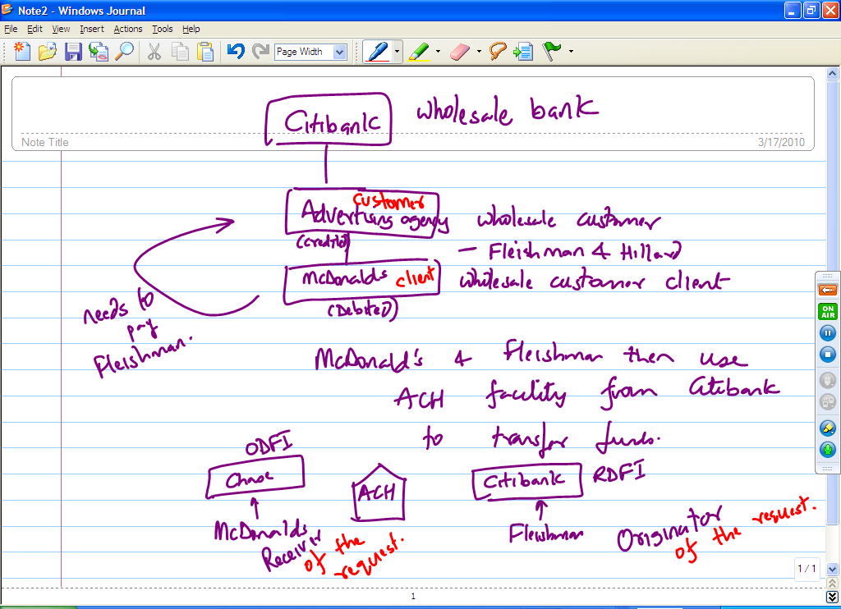

My specific role was to set up the layout of the ACH transfer forms for Citibank’s customers so that Citibank’s customers can provide the ACH debit authorization forms to Citibank’s customers clients. (THIS IS VERY LAME!!)

I worked on batch processing of these ACH requests from our customers. The ACH credit requests from out customers were not fulfilled real time. Customers (like Fleishman & Hillard) would send us a bunch of ACH credits and we in Citibank would batch up these credit requests to send them to ACH. I worked on a timetable so that our customers are aware that in case they need to see the credit in their account today, they have a cut off time of 3 pm (Pacific time). I also worked on creating documentation for our customers to explain to them the availability windows of the funds. This document explained to them the difference between a soft post and a hard post.

**Tell me about your data mapping experience?**

In Tanu’s and Alok’s own words, we should explain what we understand by data mapping!

Imagine there being more than one data model (ER Model. ER Model also then means the tables and the columns and the data types, etc.). So, say there are 2 such data models. Say there is now a need to **consolidate** these 2 data models into one (e.g., say 2 companies are merging and their data models need to converge). Data mapping is the process of studying and finding out the relation or the correspondence between the attributes of the two entities (different columns of the two databases) and trying to remove the redundancies in the data and also trying to smoothen out the minor differences in their data types to come up with a common data type.

Another place where data mapping comes into play is when say data is coming to an application through an external source. E.g., in the Citibank project, our customers would be sending us the information about what clients to debit through a CSV file (Comma Separated Value) file that looked like:

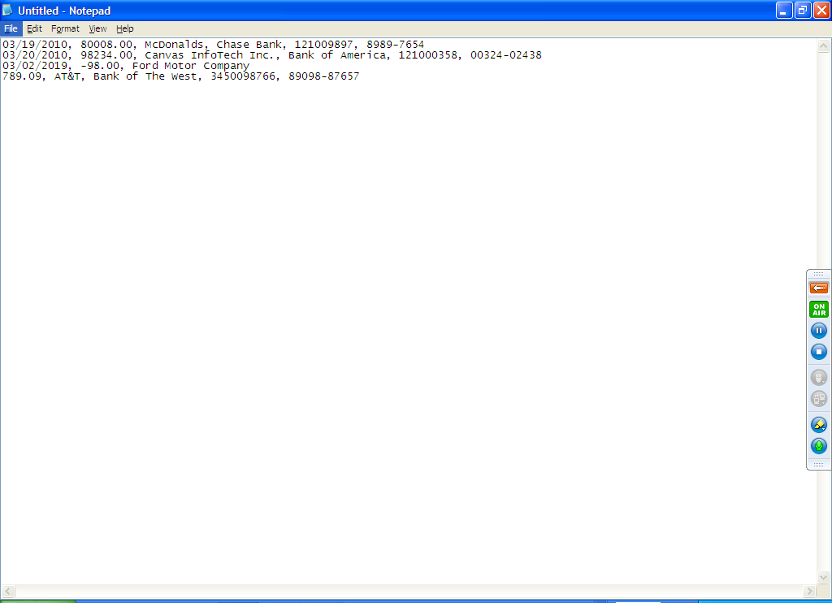

At Citibank end, I as a BA decided the process that takes this data coming in and store it in our Citibank’s database (after doing basic syntax checking on it – I had programmers write automated scripts to parse through these CSV files and make sure they are of proper syntax). This is where my data mapping experience. I had to map the data coming from our customers in csv files and map it to our database for storage. So, e.g, an exercise where I will create an Excel file and say: 1st value from CSV file goes into Column Debit_date in table “ACHTrxs”. 2nd value from CSV file goes into column Debit_amount in table “ACHtrxs”.

**Tell me about your Data Flow Diagrams experience?**

Data Flow diagrams represent how data is processed by a system in terms of inputs and outputs!

Tanu to draw a DFD. Look here for an awesome tutorial on DFD: <http://www.agilemodeling.com/artifacts/dataFlowDiagram.htm>

**What is the difference between a process flow diagram and a data flow diagram?**

**What do you mean by Wrote SQL queries for Business Logic?**

SQL – Structured Query Language!

It is a language to query data from databases!

SQL: Structured Query Language: Select <columnName1>, <columnName2>, <columnName3>,…. From <tableName> where some Boolean condition;

DDL: Data Definition Language: are those commands that are used to create the table or to modify a table:

CREATE Table <tableName>

(columnName1 DataType,

columnName2 DataType,

columnName3 DataType,

……

CONSTRAINT <constraintName> Primary Key(columnName));

Alter table command is used to add a column or delete a column.

DML: Data Manipulation Language: Update table (learn the syntax)

Delete from table

Insert into table

(It will be greatly beneficial to Tanu to go through 6 hours of Alok’s SQL classes which have been recorded to refresh her principles).

Do you know joins?

Tell me the difference between inner join and outer join!

What do you mean by “Wrote SQL queries for Business Logic”?

Tanu told me that one of the business requirements of this project was “Wholesale customers should be able to send their accounts receivable file to the bank” – because bank is going to be recovering money from customer’s clients. I wrote a SQL query to find out how many accounts receivables files are we getting in a period of time. There was a table called “IncomingTransactions”. The query I wrote was:

Select count(TransactionID) from IncomingTransactions where DateStamp > ‘01/01/2010’ and DateStamp < ‘03/18/2010’) and CustomerID = ‘MCDONALDS’;

(The above gives you a count of how many receivables files we received from Mcdonalds for YTD).

Another business requirement that Tanu told me was “Reconciliation statements should be available to every customer online at the end of each day”. I wrote a SQL script to find out how many customers are downloading the reconciliation statement from us each day.

There was a table called “Reconciliations”

Select count(ReconciliationStatementID) from Reconciliations where ReconciliationDate = ‘03/18/2010’ and downloadedStatus = ‘Accessed’; (When the reconciliation statement is ready, the process inserts a row in this table that shows that a new reconciliation is ready. But, the downloadedStatus column is of-course null when this insert happens. Later on, when a wholesale customer downloads the reconciliation statement, the process also updates the row for this customer with the downloadedStatus getting value ‘Accessed’;)